Asia-China-Coin-Spade-Flat Handle-Arched Foot (400-300 BCE) -H 3.13-R 2

"垂二釿," Chuí Er Jin (inscription inverted), Chui one jin, Spade, Flat Handle, Arched Foot Coin (400-300 BCE). Chuí 垂 was a place of the Liang [梁](http://en.wiktionary.org/wiki/梁)[國](http://en.wiktionary.org/wiki/國) (771-475 BCE) or Wèi (卫) State, and later was annexed by the Wèi (魏) Nation. JIN, Ancient metals weight, as well as currency. In the Warring States Period, all kingdoms regarded "JIN" as the basic unit.

垂二釿桥裆布Bridge crotch fabric vertical two Yin

length 6CM/2.36Inches, width 3.3CM/1.30Inches

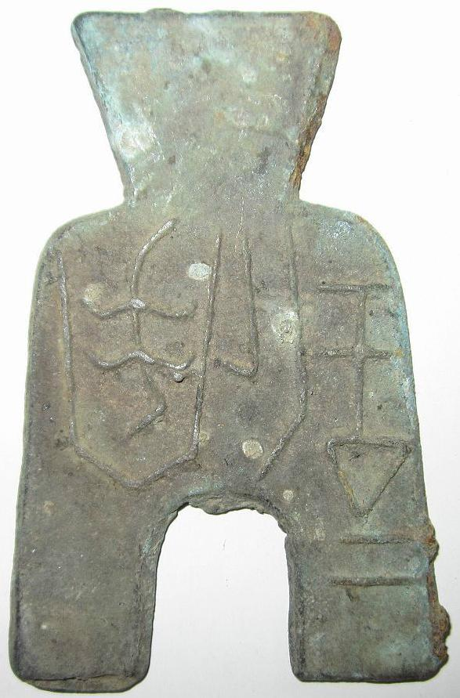

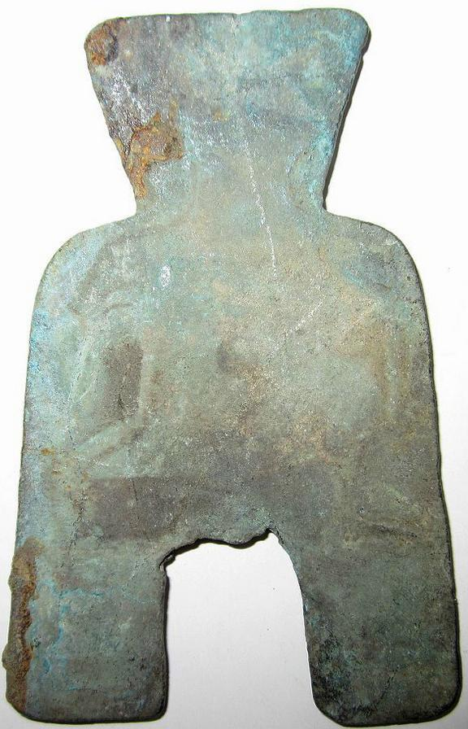

Delivery package 1 of 1

Estimated delivery Thursday, Jan 16, 2014 - Thursday, Feb 13, 2014

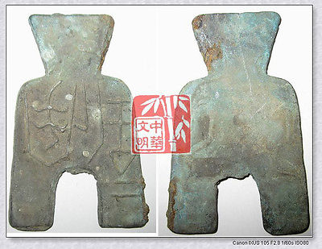

[VINTAGE SpringAndAutumnPeriod WEI MINT WEIGHT MONEY BRONZE SPADESHAPE COIN垂二釿桥裆布](http://www.ebay.com/itm/251408802794)

Item price

$9.99

Quantity

1

Item number

251408802794

Shipping service

Economy Shipping from outside US

[Leave feedback](http://feedback.ebay.com/ws/eBayISAPI.dll?LeaveFeedbackShow&useridfrom=802-867&useridto=bcculture&item=251408802794&transactid=0) [Contact seller](http://contact.ebay.com/ws/eBayISAPI.dll?FindAnswers&frm=3998&iid=251408802794&redirect=0&requested=bcculture) [Return item](http://return.ebay.com/ws/eBayISAPI.dll?ResolveReturn&eventName=viewSelectedItem&TransactionId=0&ItemId=251408802794)

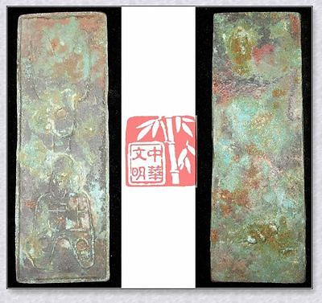

[WARRINGSTATESPERIOD ZHAO NATION MINT MONEY MODEL BRONZE SPADE-COIN PATTERN上专十二朱](http://www.ebay.com/itm/251412020859)

Item price

$59.99

Quantity

1

Item number

251412020859

Shipping service

Economy Shipping from outside US

[Leave feedback](http://feedback.ebay.com/ws/eBayISAPI.dll?LeaveFeedbackShow&useridfrom=802-867&useridto=bcculture&item=251412020859&transactid=1360127104015) [Contact seller](http://contact.ebay.com/ws/eBayISAPI.dll?FindAnswers&frm=3998&iid=251412020859&redirect=0&requested=bcculture) [Return item](http://return.ebay.com/ws/eBayISAPI.dll?ResolveReturn&eventName=viewSelectedItem&TransactionId=1360127104015&ItemId=251412020859)

Sold by

[lengxue](http://myworld.ebay.com/lengxue) ( [27](http://feedback.ebay.com/ws/eBayISAPI.dll?ViewFeedback&userid=lengxue)  )

+ Show additional actions

Delivery package 1 of 1

Estimated delivery Wednesday, Jan 8, 2014 - Thursday, Jan 16, 2014

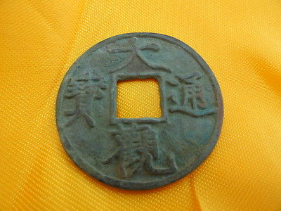

[Artwork Chinese ancient trade tools, bei song period ,da guan tong bao,font](http://www.ebay.com/itm/141146766610)

Item price

$1.85

Quantity

1

Item number

141146766610

Shipping service

ePacket delivery from China

[Leave feedback](http://feedback.ebay.com/ws/eBayISAPI.dll?LeaveFeedbackShow&useridfrom=802-867&useridto=lengxue&item=141146766610&transactid=0) [Contact seller](http://contact.ebay.com/ws/eBayISAPI.dll?FindAnswers&frm=3998&iid=141146766610&redirect=0&requested=lengxue) [Return item](http://return.ebay.com/ws/eBayISAPI.dll?ResolveReturn&eventName=viewSelectedItem&TransactionId=0&ItemId=141146766610)

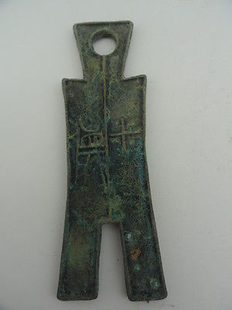

[Tools of the trade in ancient China,spring and autumn period, trousers shape](http://www.ebay.com/itm/141146767474)

Item price

$8.99

Quantity

1

Item number

141146767474

Shipping service

ePacket delivery from China

[Leave feedback](http://feedback.ebay.com/ws/eBayISAPI.dll?LeaveFeedbackShow&useridfrom=802-867&useridto=lengxue&item=141146767474&transactid=0) [Contact seller](http://contact.ebay.com/ws/eBayISAPI.dll?FindAnswers&frm=3998&iid=141146767474&redirect=0&requested=lengxue) [Return item](http://return.ebay.com/ws/eBayISAPI.dll?ResolveReturn&eventName=viewSelectedItem&TransactionId=0&ItemId=141146767474)

### Shipping address

Ralph J Coffman Jr  
149 Atlantic Ave   
Swampscott MA 01907-2427  
United States

Phone number  
781 584 7091

### Order total

Subtotal $80.82

Shipping $52.00

Shipping discount -$3.00

#### Total

## $129.82

[View PayPal transaction](http://payments.ebay.com/ws1/eBayISAPI.dll?IntermediateResolutionInfo&itemid=0&transId=0&pn=UnifiedCheckoutSummaryRedirect2PP&qs=itemid%3D0%26transId%3D0%26buyerorseller%3D0%26)

### Order information

Order placed on  
Sunday, Dec 29, 2013

Having a problem with this purchase?  
[Resolve problem](http://res.ebay.com/ws/eBayISAPI.dll?ResolutionCenter)

Payment method   
PayPal

Payment date  
Sunday, Dec 29, 2013